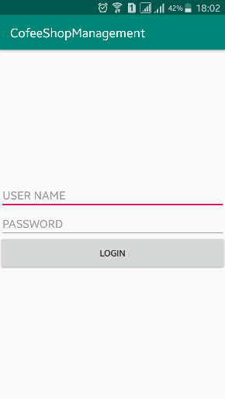TESTING UNIT:

1. This is the first display when you open the app:

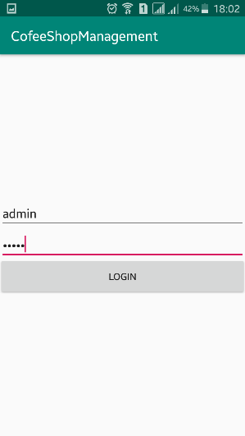

1. To login into the Order Page you insert: USERNAME

as admin and PASSWORD is also admin

1. 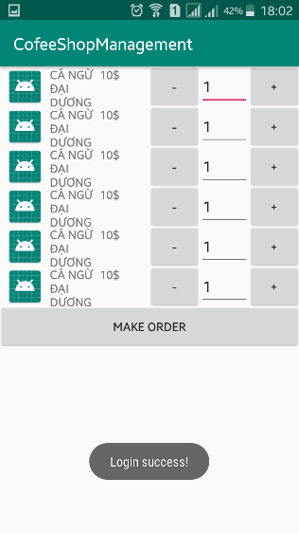When you click the login, It will turn to the menu page   
   and it has a comment bellow that you login is successful.

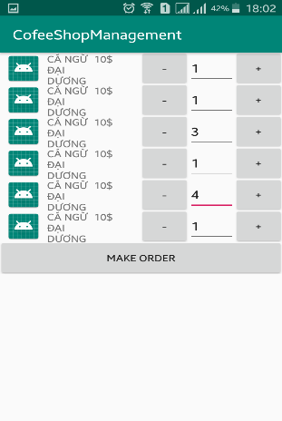

1. In the menu page, you can change the number of the food

that customer order. Like I test is that I change the number of

the food by insert by keyboard.

1. 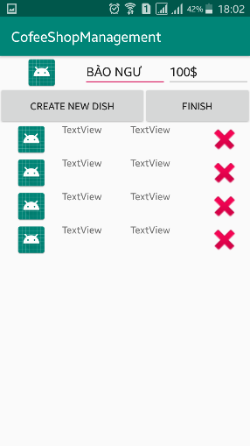After note all the food that customers order. You click on the

button MAKE ORDER to save the order and it turn into the

display that show all of you just make the order and show how

much money of the order.

1. 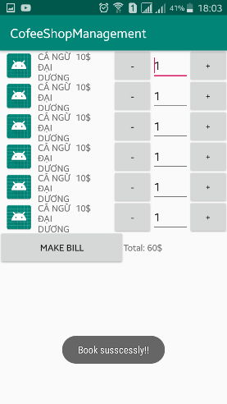When you click on the Finish Button, you will turn into the

display that show you the order again to make sure that

order is right.

1. When you click on the Make Bill that you finish of the order

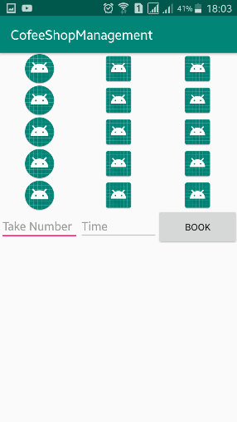and change to the display that you can book the table.\

1. 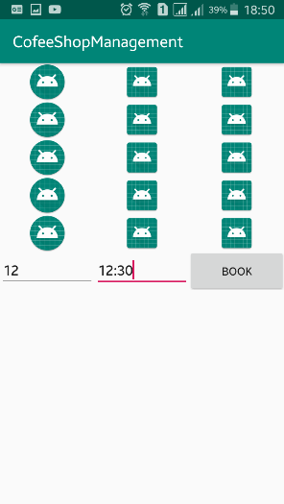In this display you can insert the table number and the time

that the customer book.

1. 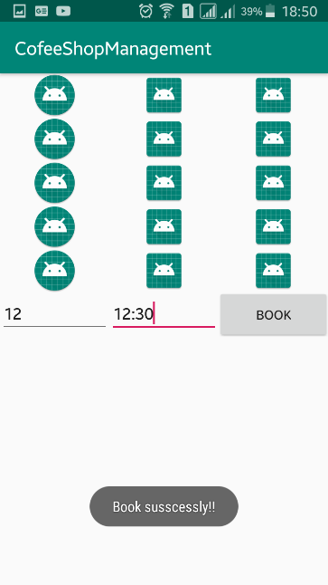When you insert the number and the time, when you

click on the button book, it wil inform that Book Succesfull.

After test the software, I see that the software have 4 function that the customer require: Book, Menu, Payment, Login.